* PhD Annual Review System

Iteration 2

**Neha Joshi** - Product Owner

**Prachi Surbhi** - Scrum Master

**Shwetima Sakshi** - Developer

**Prachi Surbhi** - Developer

**Harshvardhan Surolia -** Developer

**Shashank Jagtap -** Developer

**Will Harper -** Developer

**Stakeholders**: This system will be used by the cse department to evaluate the reports submitted by PhD students. This system will be used by faculty members and students where faculty members can view the reports and submit their comments about the report. The student can submit their documents for the faculty members to review.

**Recurring Client Meeting Time**

- Every Wednesday at 2 pm

**Customer Meeting Date and time:** Oct 11, 2023 2:00 PM

**Meeting place**: Peterson 408

**Client feedback:**

1. Client has asked us to make some changes in the document submission page such as drop down to select year → This is already done in this iteration itself
2. Check boxes for milestone passed
3. If performance is unsatisfactory then give a text box for improvement plan or else don’t show it
4. Yes or No checkbox for support in last semester
5. Report submission option to upload the report file → This is also done in this iteration.

Remaining item and feature enhancement will be done in the next iteration.

**User Stories Implemented:**

1. **Student Document Submission Page**

As a student, when I login into the system, I want to fill out a mandatory form and the student should also be able to submit his Ph.D. report and his resume which can be later reviewed by the committee members. This story had a lot of sub-tasks such as creating tables for student documents, creating correct association between tables and defining correct foreign key constraints, writing backend code for documents submission, writing backend code to connect toS3, writing backend code to create form with validation, creating the front-end for document submission page.

1. **Student can select his own committee members**

As a student user with an account on the Ph.D. Annual Review System

So that my committee can view my document submission

I want to submit my committee to the system to be stored in the database. The coding is completed for this user story but we decided not to deploy this story in this iteration as testing wasn’t completed for this story. This story will be deployed in the next iteration. Attaching screenshot below for this story.

**Design Diagram of Current Implementation:**

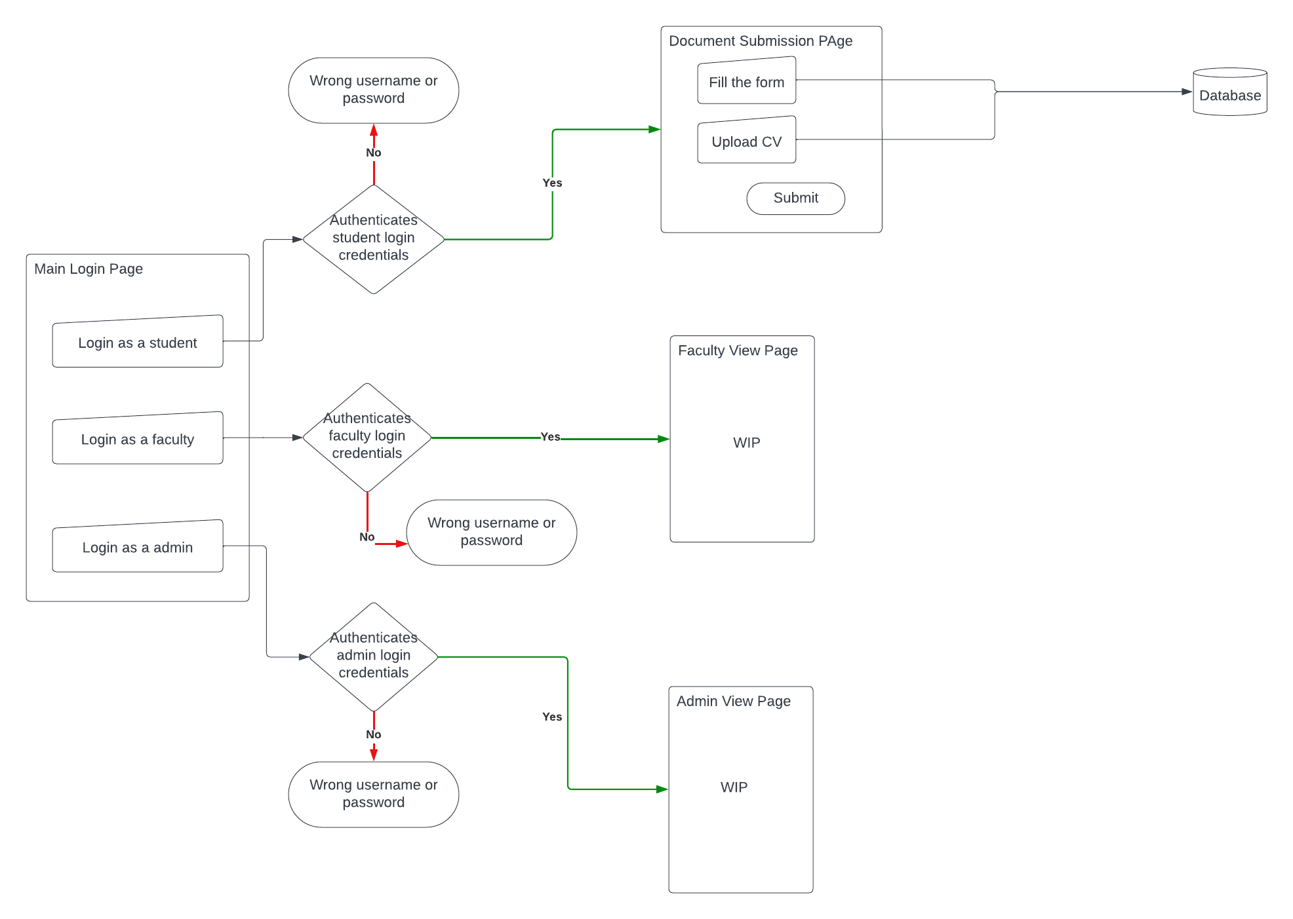

**Design Diagram of Target Implementation:**

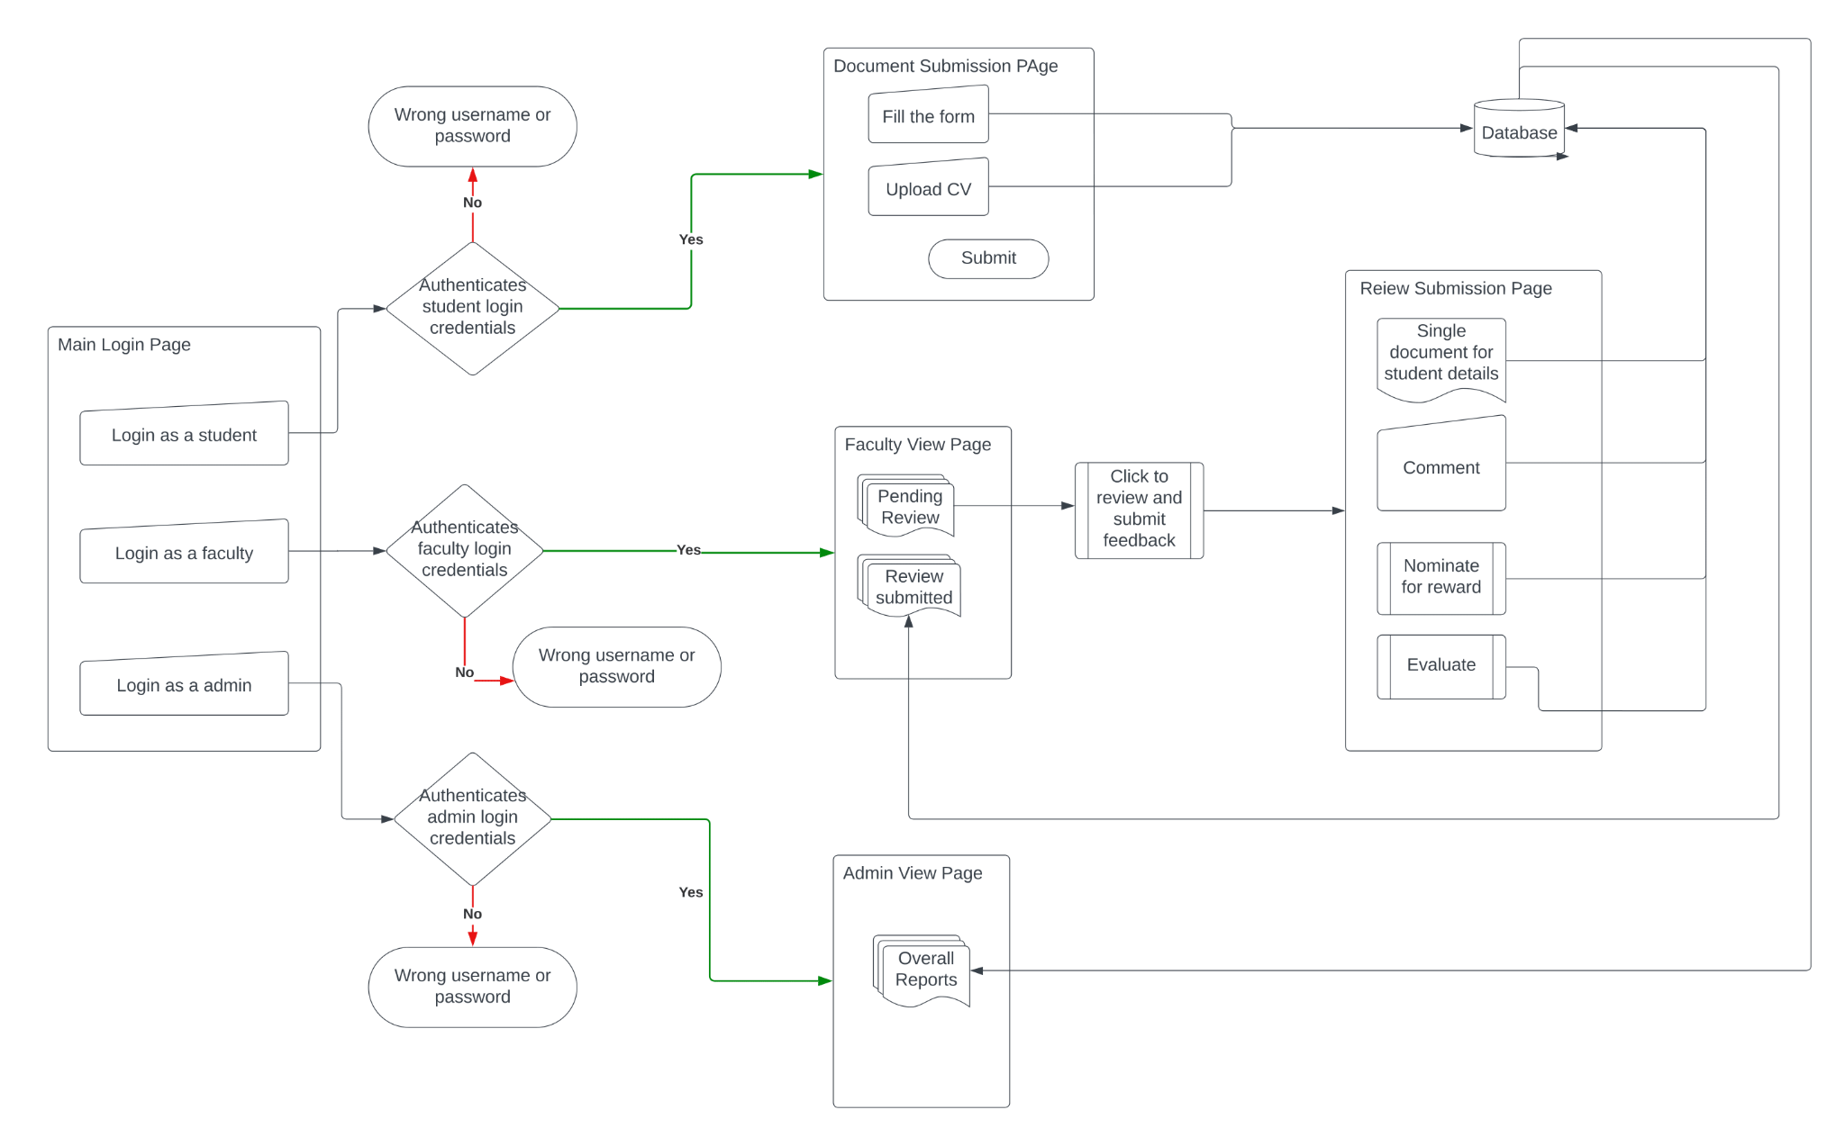

**Changes made to the UI**

Submit Documents

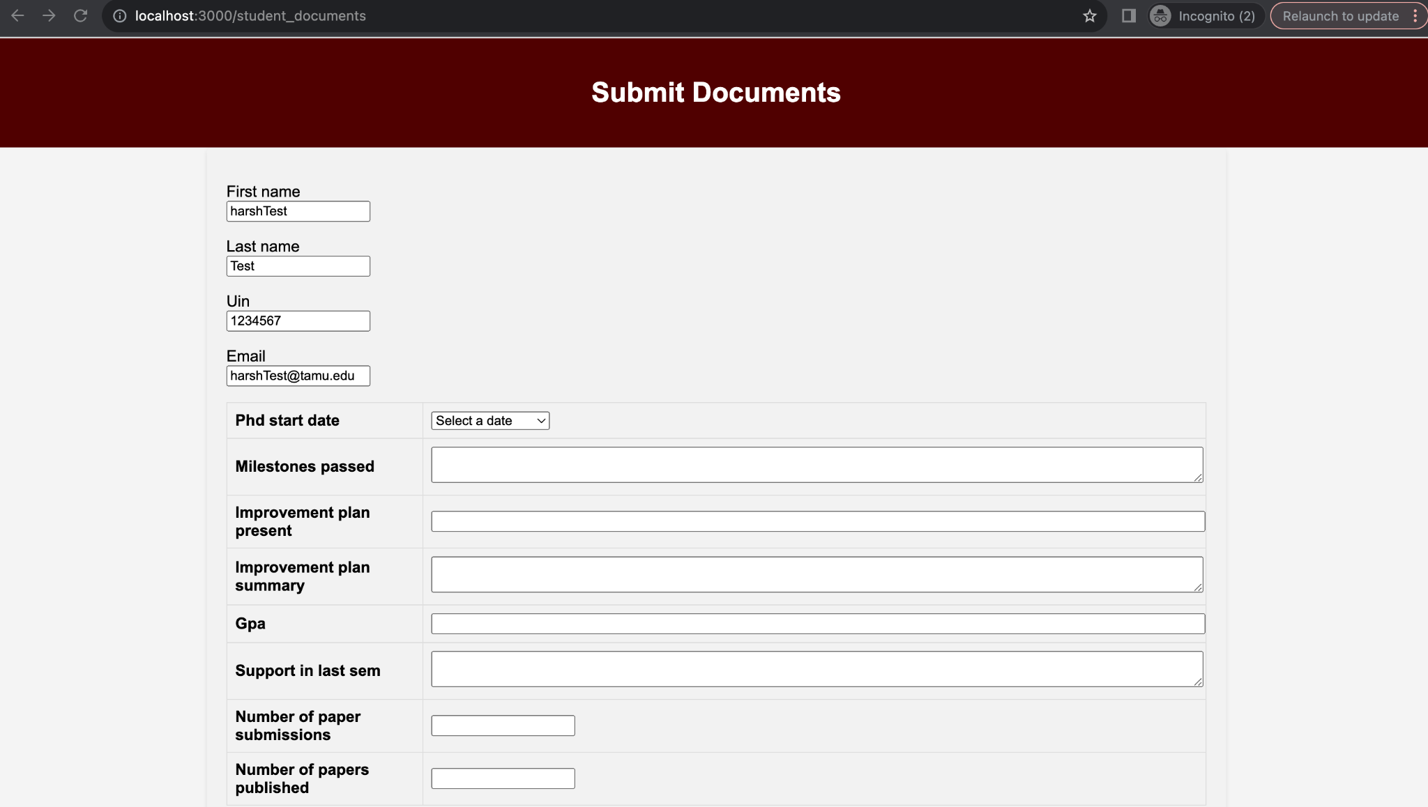

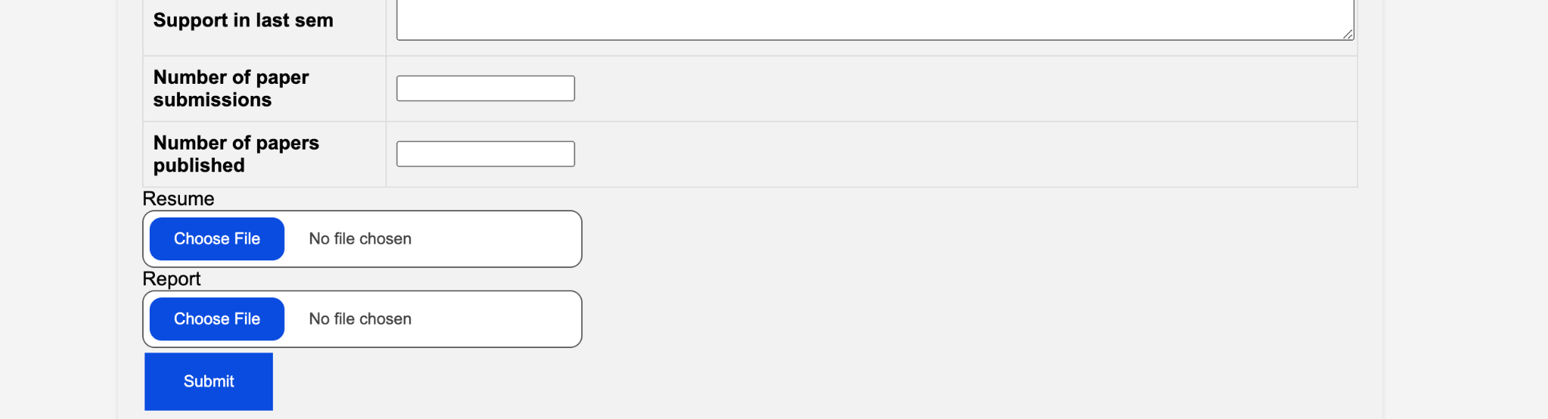

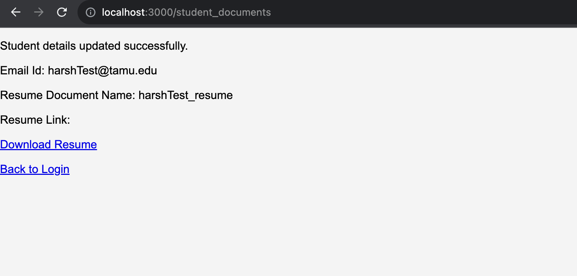

**Screenshot of Committee Selection by student (This feature will be deployed in next iteration as testing is pending for this feature)**

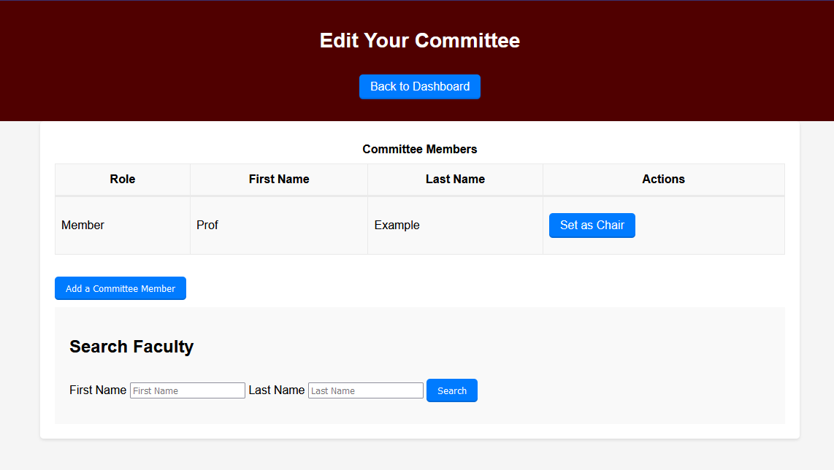

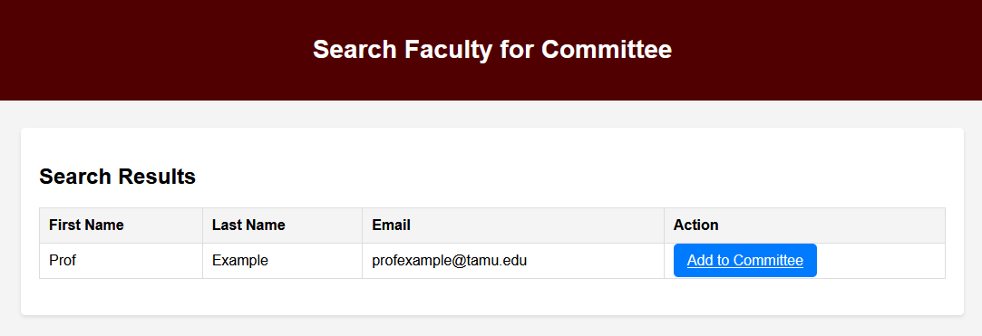

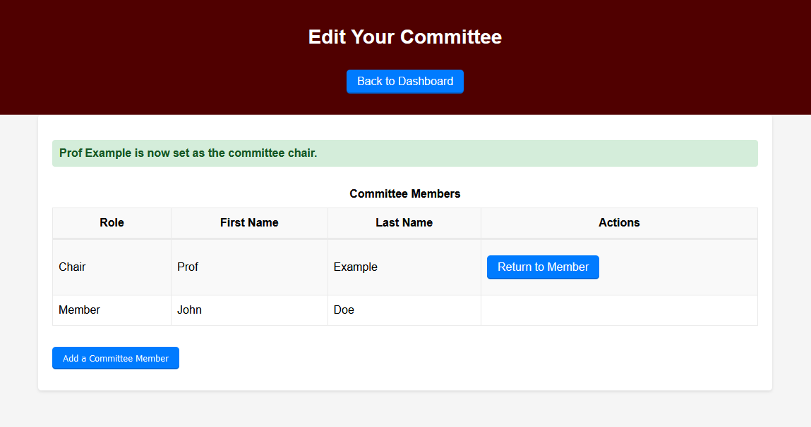

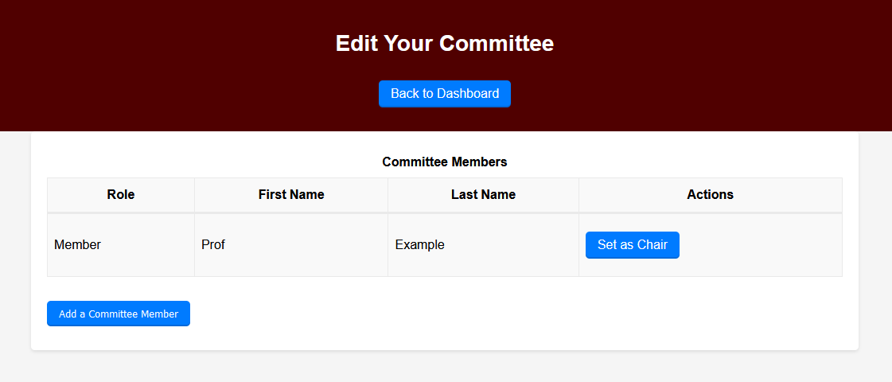

**Changes made to the initial design**

* Moving from postgres to S3 to store resume and cv
  + At the outset of this iteration, we intended to store the document that has to be submitted by the student in postgres but we realized that if we store the documents in postgres we will have performance overhead and also it was increasing the complexity. To solve this problem we decided to store the documents in S3 and in postgres we are just storing the path in which the documents are stored on S3 bucket.

**User stories not completed in this iteration**

* Creating a dashboard for the faculty
  + We planned to create a dashboard for the faculty members when they login into the system, they should be able to see the students for whom they need to submit their review. We dedicated a lot of our time in finalizing the schema for the table and changing our datastore from postgres to S3 for document storage. Although doing this made us realize that designing takes time and we should give more time to this as last minutes changes to design take up a lot of time as we need to make a lot of code changes and test the functionality again
  + We just finished designing the database schema and creating association among tables for this story. We will start working on this story from the next iteration.
* Committee selection by student
  + We have finished the front-end and back-end for this feature but we still have to write the test cases for this feature, so we decided not to deploy this feature as it may break our existing feature. Attached the screenshot for the UI that was created for this feature, will deploy in next iteration.

**Code and Test Evaluation**

Cucumber tests: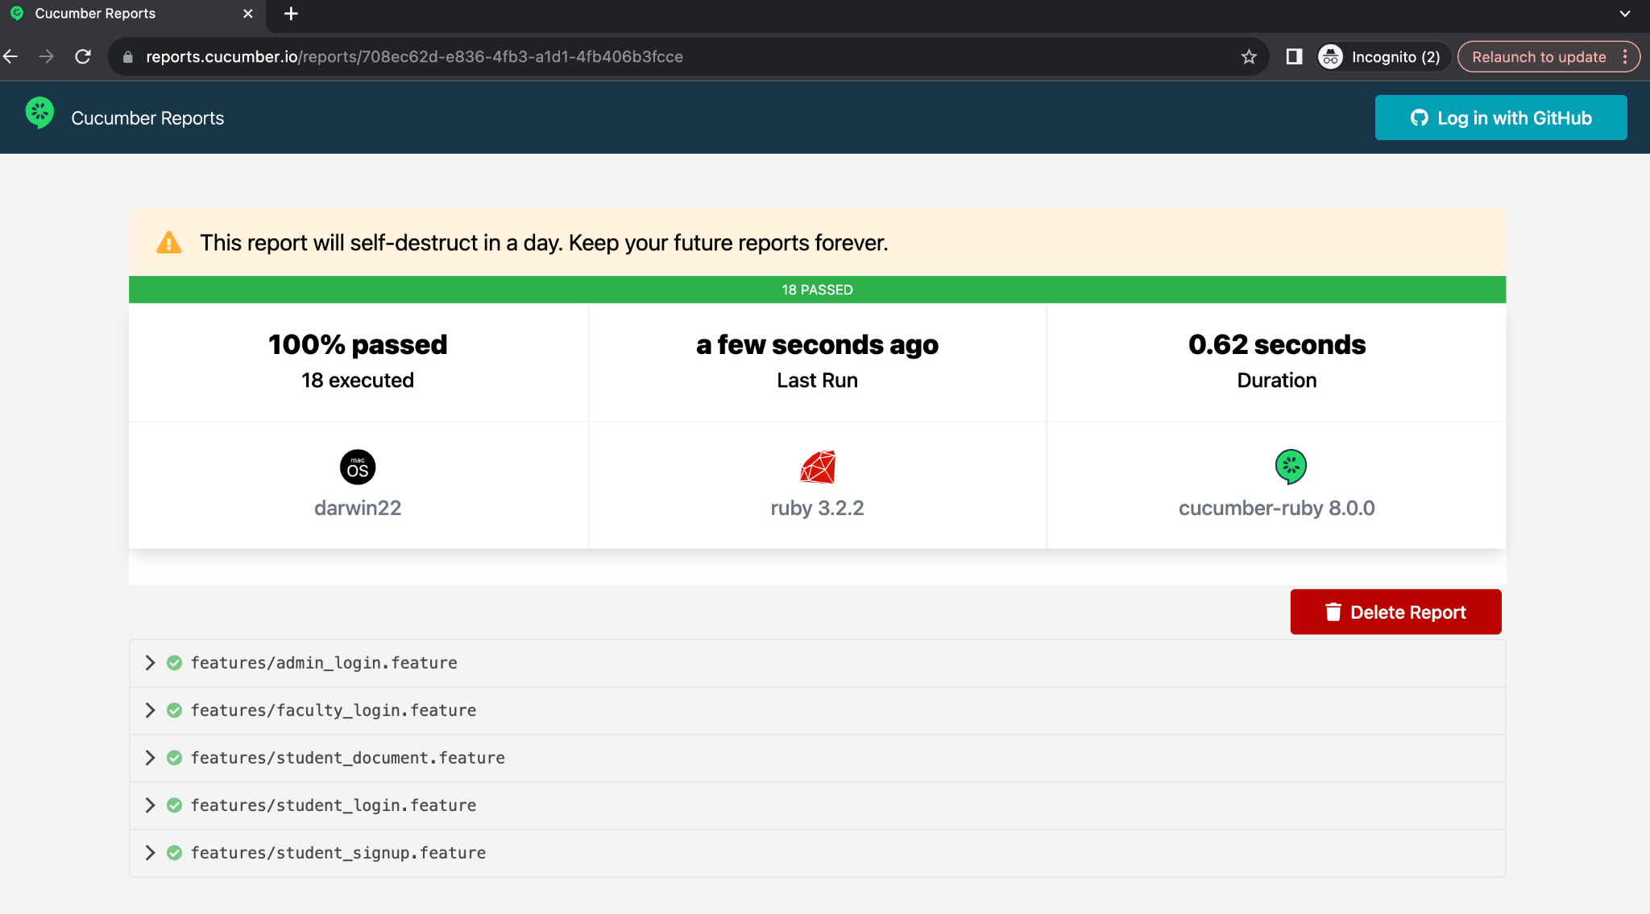

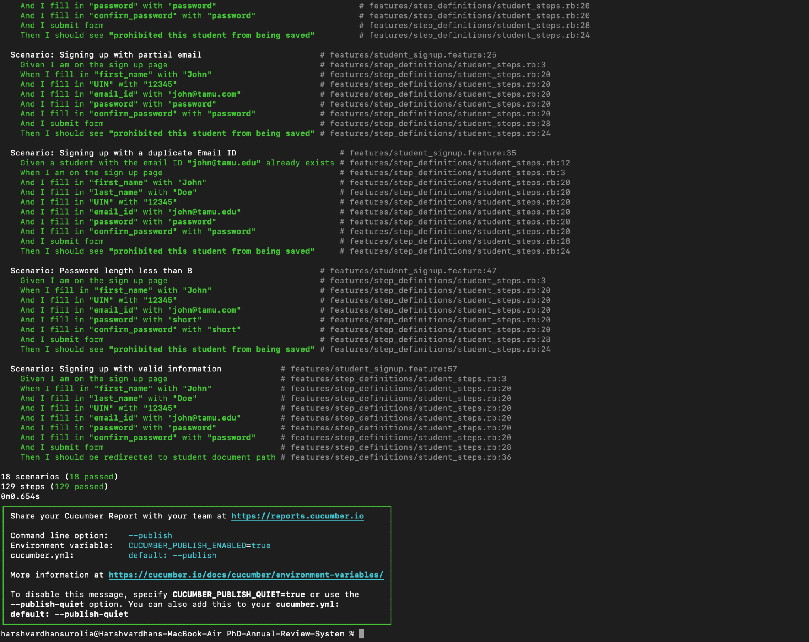

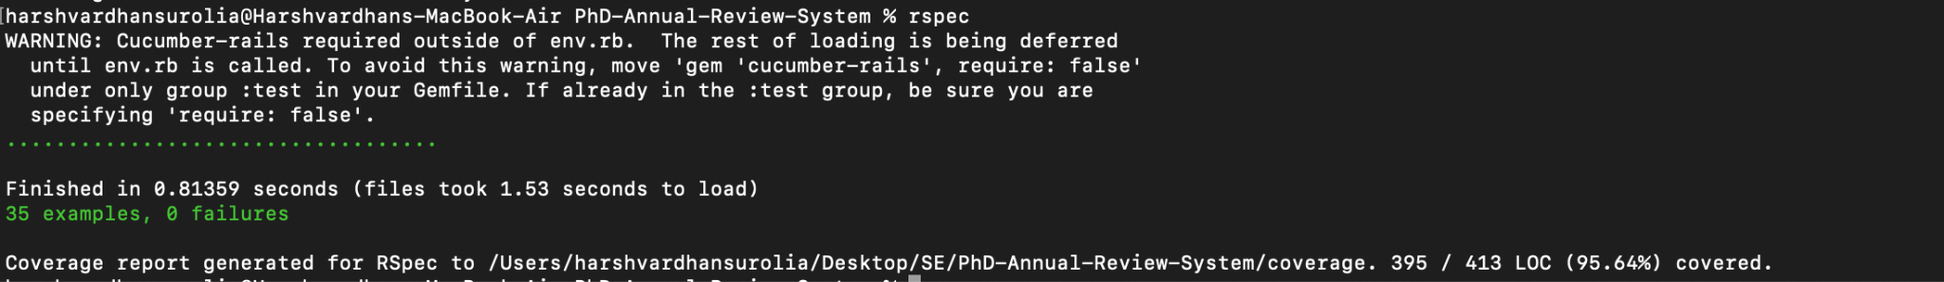

Test coverage:

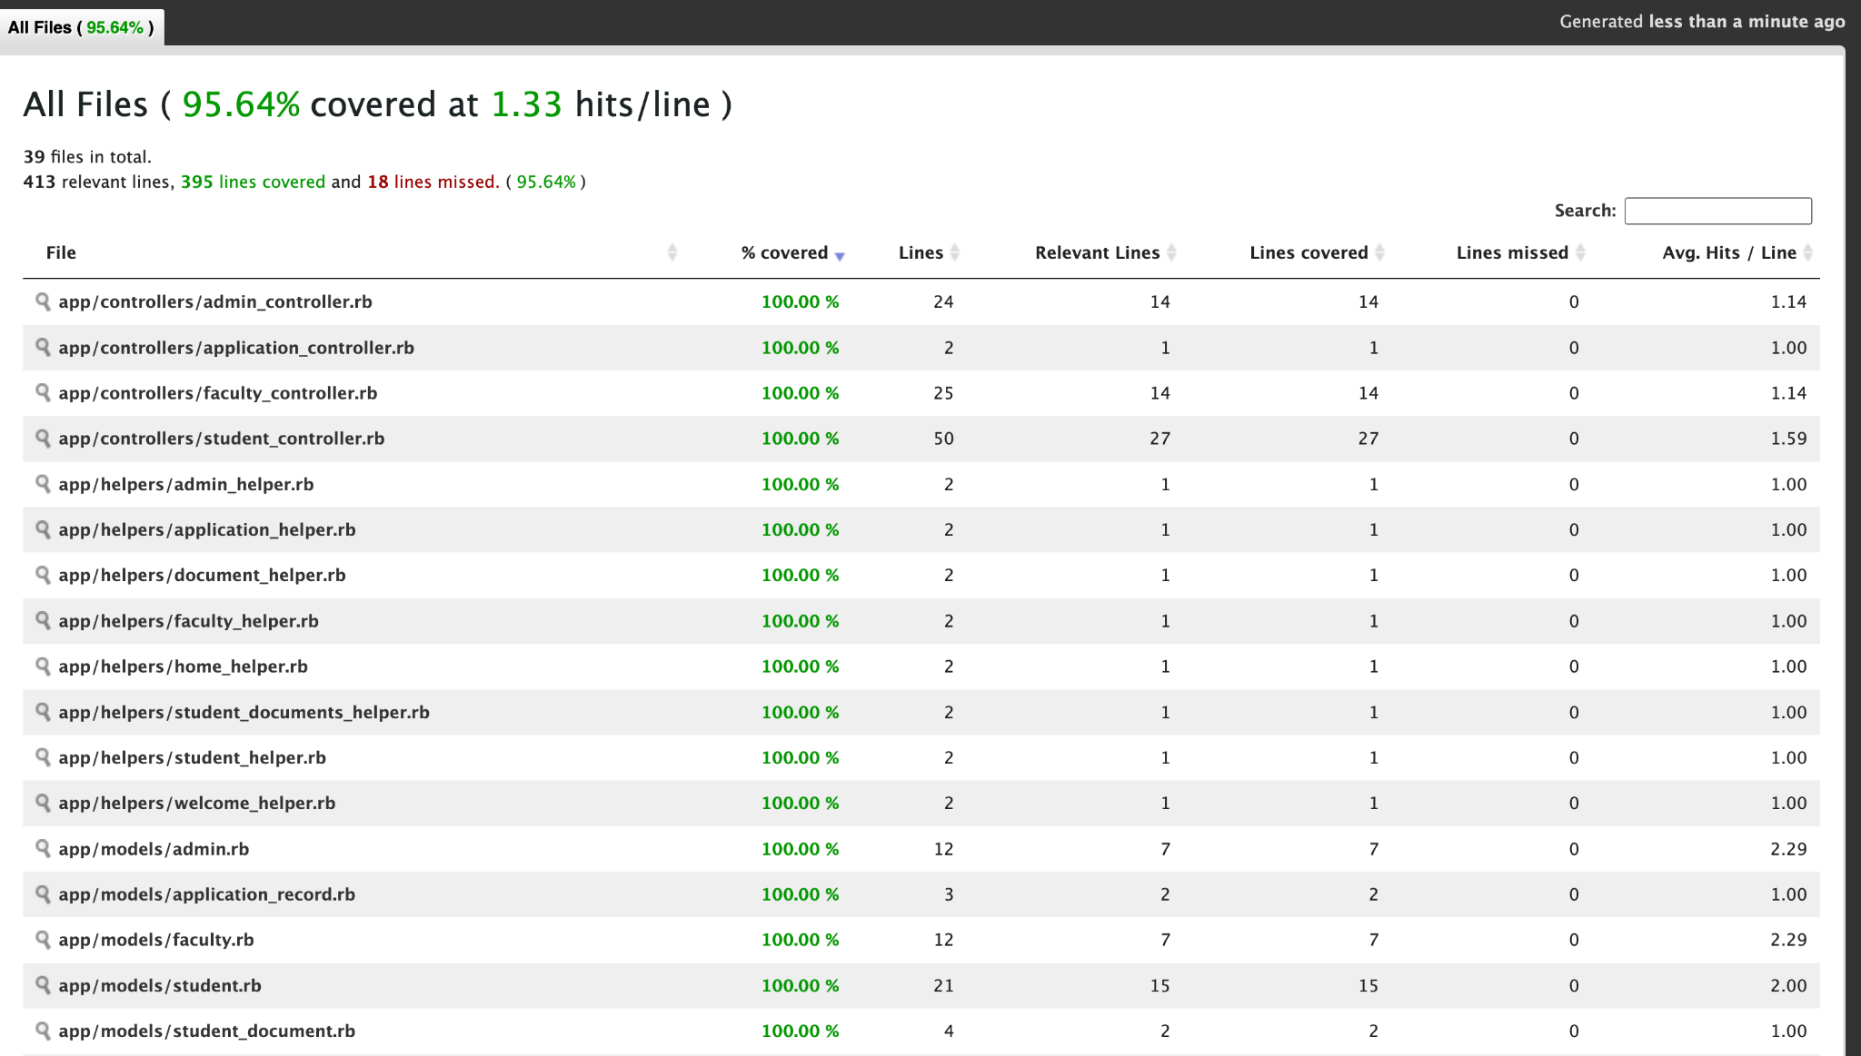

**Relevant Links**

Project Management (Github):

<https://github.com/orgs/PhD-Annual-Review-System/projects/2>

Github Repository:

<https://github.com/PhD-Annual-Review-System/PhD-Annual-Review-System>

Heroku:

<https://phd-review-app-0416787b021c.herokuapp.com/>

**Burndown Chart**

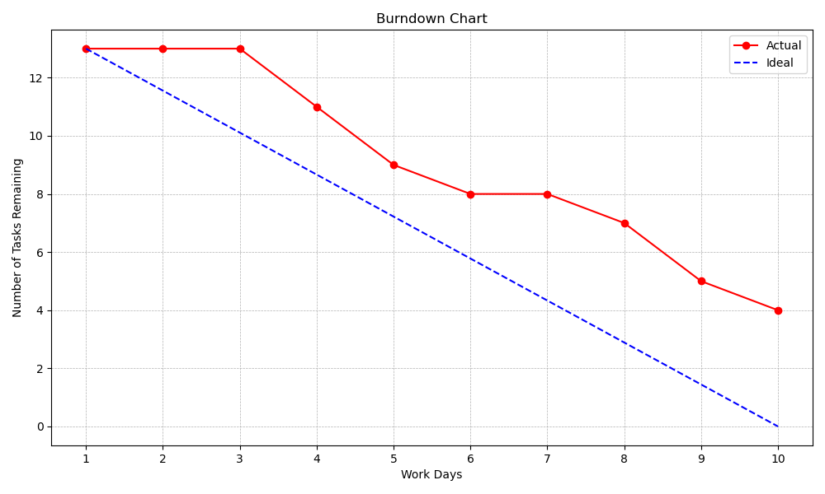

**Work Breakdown**

| Name |  |  |
| --- | --- | --- |
| Neha Joshi | 2.5 | 1.15 |
| Shwetima Sakshi | 2.5 | 1.15 |
| Prachi Surbhi | 2 | 0.92 |
| Harshvardhan Surolia | 2 | 0.92 |
| Shashank Jagtap | 2 | 0.92 |
| Will Harper | 2 | 0.92 |